Implementation of a Simple Code Generator Using Three Address Code (TAC) in C

Aim:
To write a C program to implement a simple code generator that converts Three Address Code (TAC) into target machine instructions using MOV, ADD, SUB, MUL, and DIV instructions.
Algorithm:
- Start the program.
- Declare variables to store the result, operands, operator, and Three Address Code.
- Read Three Address Code statements from the user until END is entered.
- Check whether the statement is an arithmetic operation or a simple assignment.
- For arithmetic operations:
  - Move the first operand into a register using MOV.
  - Perform the operation using ADD, SUB, MUL, or DIV.
  - Move the result from the register to the destination variable.
- For simple assignments, generate a MOV instruction.
- Display the generated target code.
- Stop the program.

Pseudocode:
BEGIN
DECLARE result, op1, op2, oper, tac
SET i = 0
PRINT "Enter Three Address Code"
PRINT "Enter END to finish"
REPEAT
READ tac
IF tac starts with "END" THEN
BREAK
END IF
IF tac contains arithmetic operation THEN
EXTRACT result, op1, oper, op2
PRINT "MOV R[i], op1"
SWITCH oper
CASE '+':
PRINT "ADD R[i], op2"
CASE '-':
PRINT "SUB R[i], op2"
CASE '*':
PRINT "MUL R[i], op2"
CASE '/':
PRINT "DIV R[i], op2"
DEFAULT:
PRINT "Invalid operator"
STOP
END SWITCH
PRINT "MOV result, R[i]"
ELSE IF tac contains simple assignment THEN
EXTRACT result, op1
PRINT "MOV result, op1"
ELSE
PRINT "Invalid Three Address Code"
END IF
INCREMENT i
UNTIL END
STOP
Program:
#include <stdio.h>
#include <string.h>
int main() {
char result[20], op1[20], op2[20], oper;
char tac[100];
int i = 0;
printf("Enter Three Address Code:\n");
printf("Enter each statement on a separate line.\n");
printf("Enter END to finish.\n");
while (1) {
fgets(tac, sizeof(tac), stdin);
if (strncmp(tac, "END", 3) == 0)
break;
if (sscanf(tac, "%19s = %19s %c %19s",
result, op1, &oper, op2) == 4){
printf("MOV R%d, %s\n", i, op1);
switch (oper) {
case '+':
printf("ADD R%d, %s\n", i, op2);
break;
case '-':
printf("SUB R%d, %s\n", i, op2);
break;
case '*':
printf("MUL R%d, %s\n", i, op2);
break;
case '/':
printf("DIV R%d, %s\n", i, op2);
break;
default:
printf("Invalid operator\n");
return 1;
}
printf("MOV %s, R%d\n", result, i);
}
else if (sscanf(tac, "%19s = %19s",
result, op1) == 2) {
printf("MOV %s, %s\n", result, op1);
}
else{
printf("Invalid Three Address Code\n");
}
i++;
}
return 0;
}
Output:
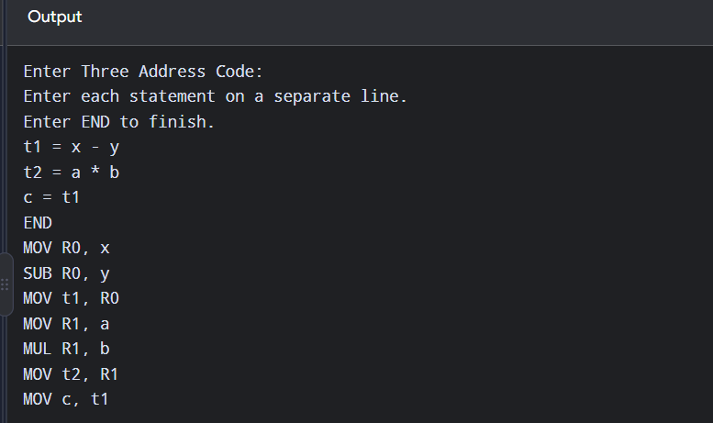
Result:
Thus, the C program to implement a simple code generator that converts Three Address Code into target machine instructions using MOV, ADD, SUB, MUL, and DIV instructions was written and executed successfully.

